**Experiment 23**

**AIM :**

To design DFA of odd number of a’s in automata.

**Design and output:**

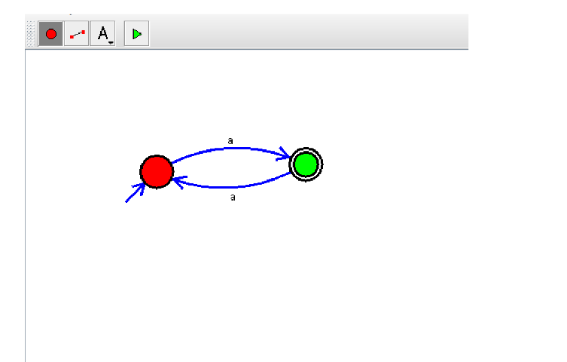

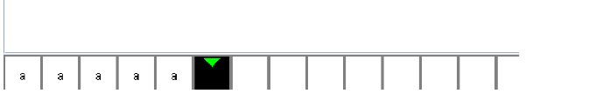

**Result:** Thus designing DFA of odd number of a’s is done and verified by giving sample inputs.